AP Calc AB Name: _______________

______________ _____________

WS Assessment

Target 25:

Volume: cylinder method

Revolving around axis

**I can:**

* Calculate the volumes of solids of revolution using the definite integral

Unit 8: Applications of Integration

HW Target 25 Unit 8 Progress Check FRQ

Suppose we want to rotate the region bounded by the curve y = 2x2 – x3 ; y = 0 around the y-axis.

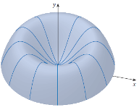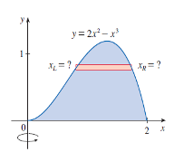

→

Using disc method, we can see that having to find the radius R(y) by solving y = 2x2 – x3 for x, then use the Disc method is difficult. (It is doable for your extra credit). There is an easier method called Cylindrical / Shells method and detail as below

Recall the formula of the cylinder of the cylinder shell below

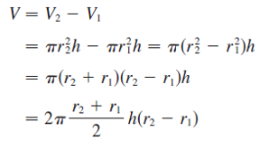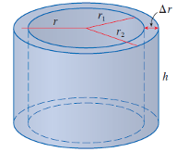

If we let Δr = r2 – r1 and r = ½ (r2 + r1) (Average radius), then volume V = 2πr h Δr

**Volume = (circumference)(height)(thickness)**

Now, think of rotating y = *f*(x) (for a <x < b) about the y-axis to get the solid on the right.

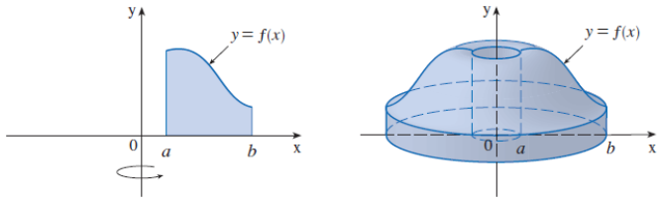

When we divide the interval [a, b] into n subinterval rectangle of equal width Δx and f(xi) is the height, where xi is the midpoint. When rotating, each rectangle strip will create a cylinder shell, whose average radius r = xi; height h = f(xi) and thickness Δr = Δx.

The volume of each shell by formula above is Vi = (2πr) (h) (Δr) = (2π xi) f(xi) Δx.

The total volume obtained by taking limit of the sum as n → infinitive is

$$V=\int_{a}^{b}{2π x f\left(x\right) dx}$$

Find the volume of the region bounded by the curve y = 2x2 – x3 ; y = 0 rotate around the y-axis

Let S be the solid obtained by rotating the region shown in the figure about the y-axis.

Show the x-intercept, find the volume and sketch the solid.

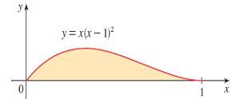

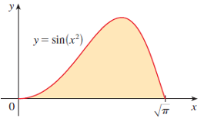

Find the volume of the solid obtained by rotating the region bounded by y = x – x2 and y = 0 about the line x = 2. Sketch the solid.

Find the volume of the solid obtained by rotating the region bounded by y = 7; y = x ½ ; x = 0 ;

x = 4 bout the line x = 0. Sketch the solid.

Find the volume of the solid obtained by rotating the region bounded by y = – x2 + 7; y = x2 + 5 and about the line x = 3. Sketch the solid.

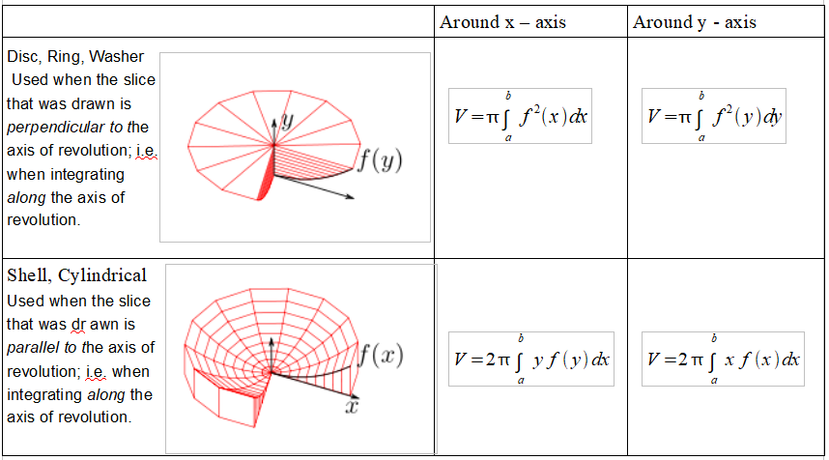

Let S be the region under the curve $y=\sqrt{x}$, line y = 0 and x = 1 Rotate S around the x-axis. Find the volume of the solid using both methods: disc and cylinder and sketch to illustrating.

Let S be the region under the curve $y=\sqrt{x}$, line y = 0 and x = 1 Rotate S around the y-axis. Find the volume of the solid using both methods: disc and cylinder and sketch to illustrating.

Let S be the region between the curve y = x and y = x2. Rotate this region around the both axis and find the volume of the solid using both methods and sketch to illustrating. (4 in one)

**Assessment**

Let R be the region enclosed by y = 2x2 and y = x4 – 2x2 in the right half-plane.

Find the area of R. Rotate R around the y-axis and find the volume generated. Disc or Cylinder? Only one method is possible. (Answer: 32pi/3)

Let S be the region between the curve y = 2x and y = x2/2. Rotate this region around the both axis and find the volume of the solid using both methods and sketch to illustrating. (4 in one)